Question 1 Output –

1. python pacman.py -l tinyMaze -p SearchAgent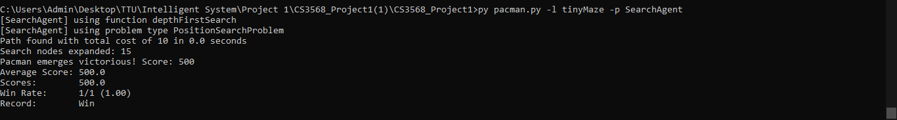
2. python pacman.py -l mediumMaze -p SearchAgent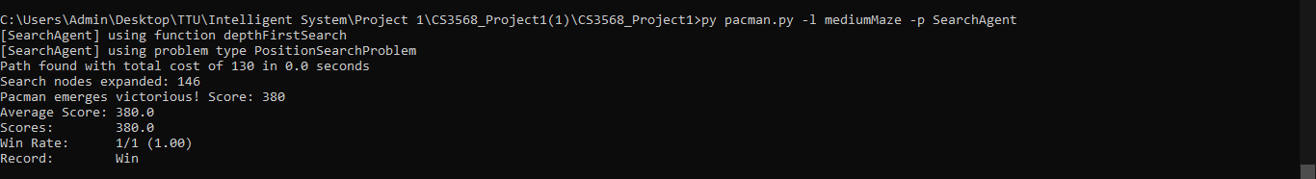
3. python pacman.py -l bigMaze -z .5 -p SearchAgent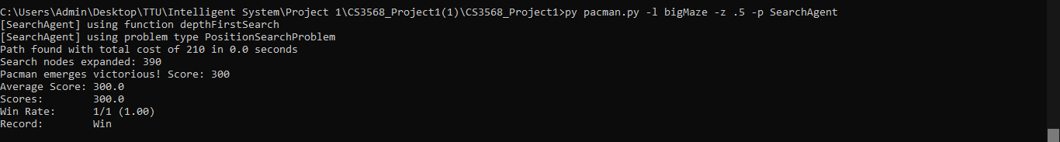

Question 2 Output –

1. python pacman.py -l tinyMaze -p SearchAgent -a fn=bfs 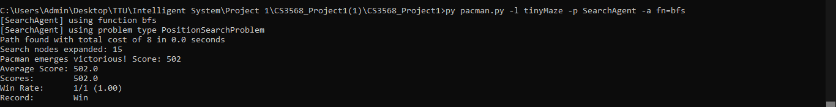
2. python pacman.py -l mediumMaze -p SearchAgent -a fn=bfs 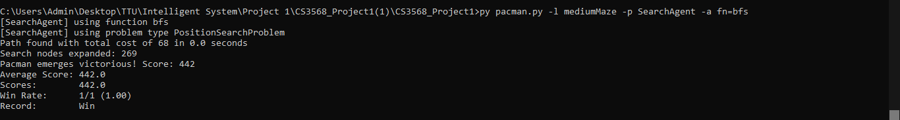
3. python pacman.py -l bigMaze -p SearchAgent -a fn=bfs 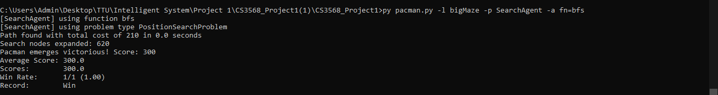

Question 3 Output –

1. python pacman.py –l tinyMaze -p SearchAgent -a fn=ucs 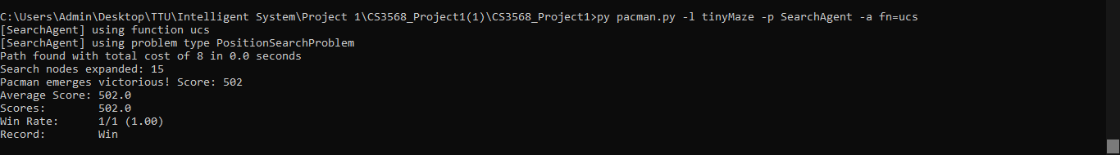
2. py pacman.py -l mediumMaze -p SearchAgent -a fn=ucs 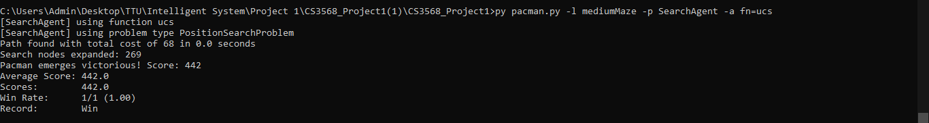
3. py pacman.py -l bigMaze -p SearchAgent -a fn=ucs 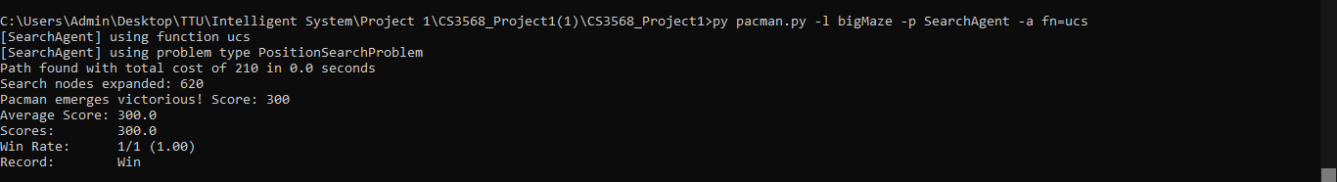
4. python pacman.py -l mediumDottedMaze -p StayEastSearchAgent 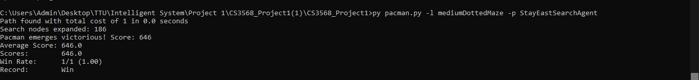
5. python pacman.py -l mediumScaryMaze -p StayWestSearchAgent 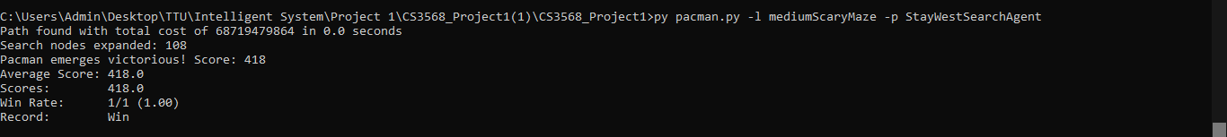

Question 4 Output –

1. python pacman.py -l tinyMaze -z .5 -p SearchAgent -a fn=astar,heuristic=manhattanHeuristic 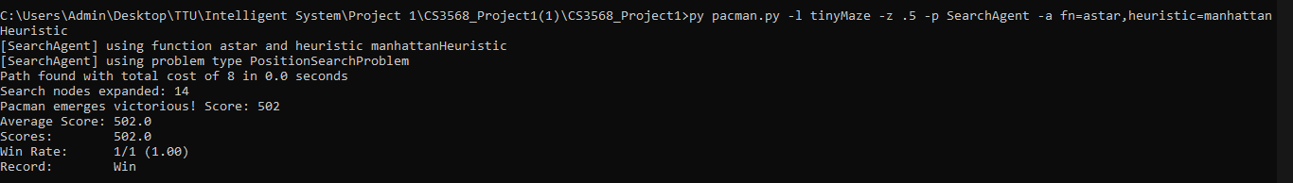
2. python pacman.py -l mediumMaze -z .5 -p SearchAgent -a fn=astar,heuristic=manhattanHeuristic 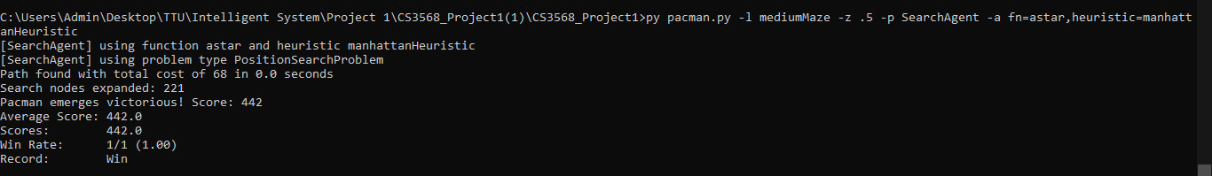
3. python pacman.py -l bigMaze -z .5 -p SearchAgent -a fn=astar,heuristic=manhattanHeuristic 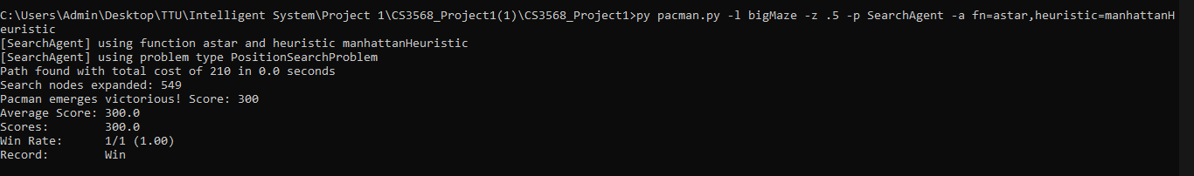

Question 5 Output –

1. python pacman.py -l tinyCorners -p SearchAgent -a fn=bfs,prob=CornersProblem 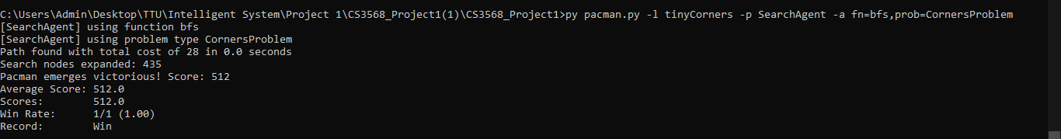
2. python pacman.py -l mediumCorners -p SearchAgent -a fn=bfs,prob=CornersProblem 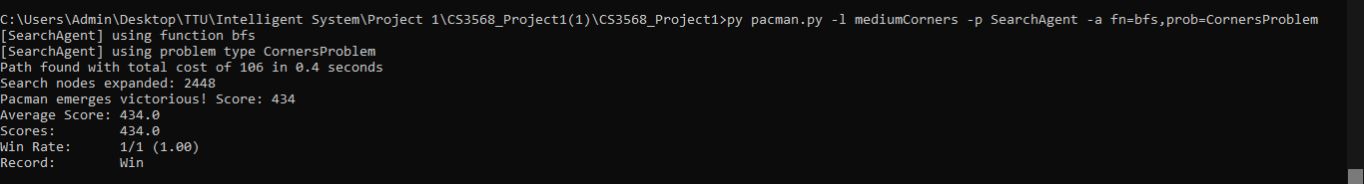

Question 6 Output –

1. python pacman.py -l mediumCorners -p AStarCornersAgent -z 0.5 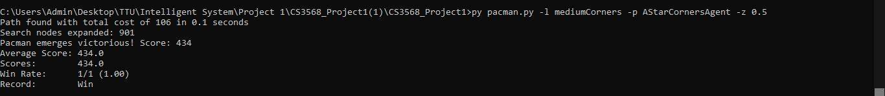

Question 7 Output –

1. python pacman.py -l trickySearch -p AStarFoodSearchAgent 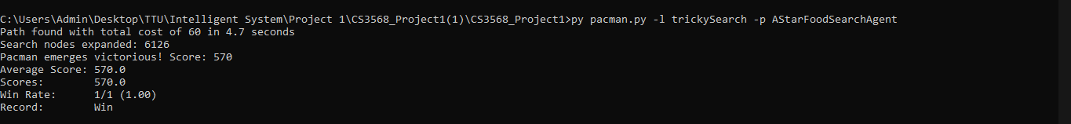

Question 8 Output –

1. python pacman.py -l bigSearch -p ClosestDotSearchAgent -z .5 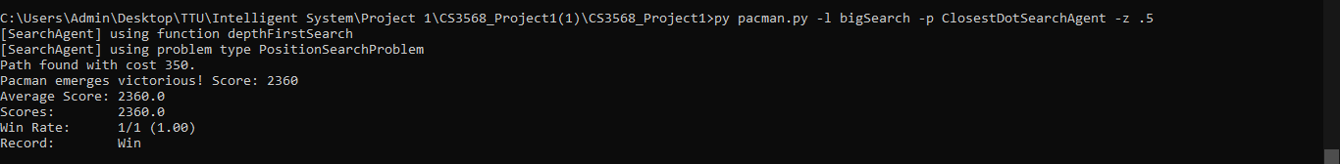
2. py pacman.py -l mediumSearch -p ClosestDotSearchAgent -z .5 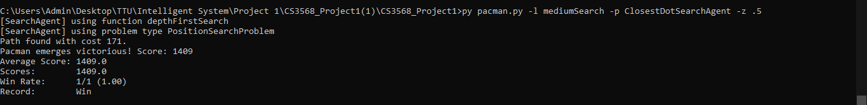
3. py pacman.py -l tinySearch -p ClosestDotSearchAgent -z .5 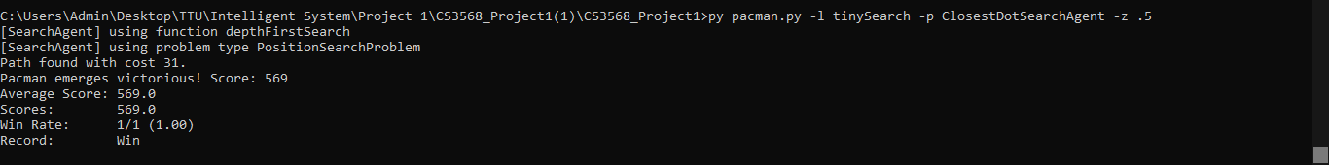

AutoGrader Output File –

